LAB ASSIGNMENT-6

-- 1.

DESC emp

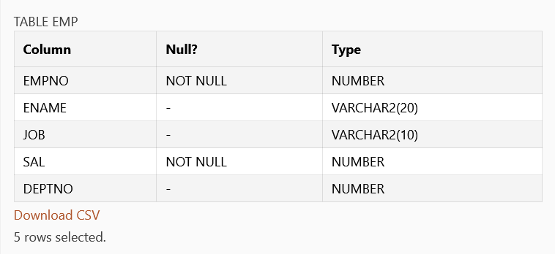

DESC dept

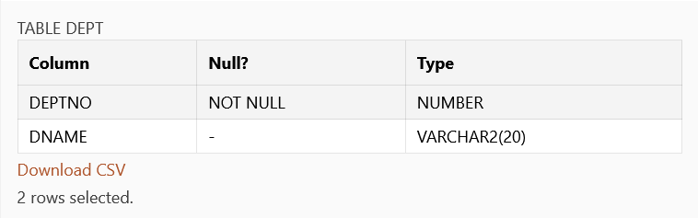

DESC S

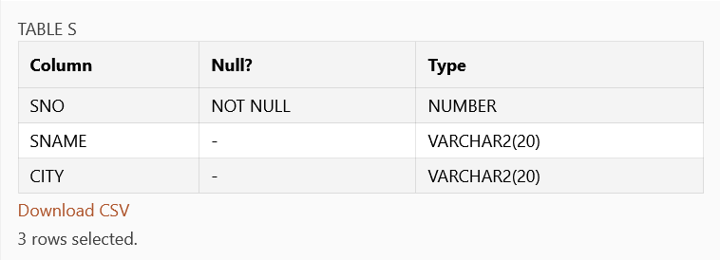

DESC P

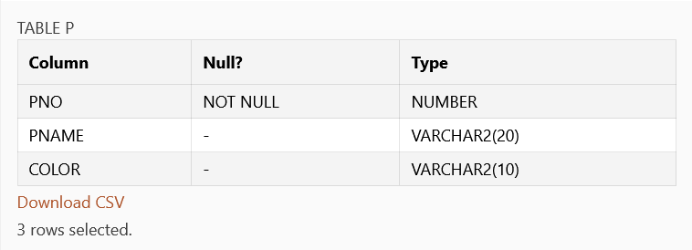

DESC J

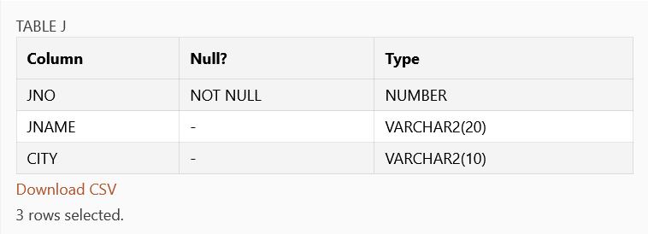

DESC SPJ

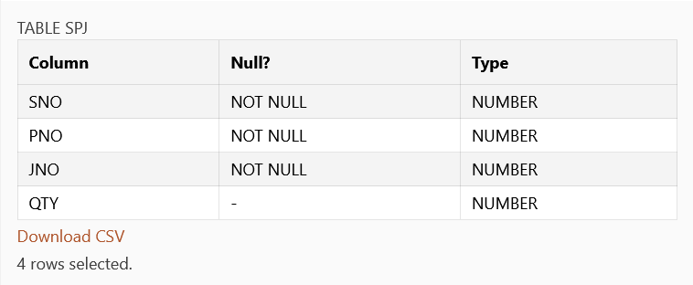

-- 2.

SELECT CONSTRAINT_NAME FROM USER_CONSTRAINTS WHERE TABLE_NAME='emp'

SELECT * FROM USER_CONSTRAINTS WHERE TABLE_NAME='emp'

-- 3.

ALTER TABLE emp MODIFY ename varchar(20)

DESC emp

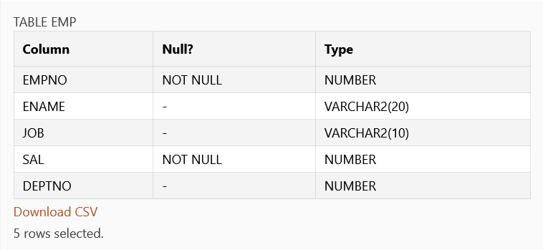

-- 4.

ALTER TABLE emp DROP CONSTRAINT FK_dept

DESC emp

-- 5.

ALTER TABLE emp

ADD CONSTRAINT FK_dept

FOREIGN KEY(deptno) REFERENCES dept(deptno)



-- 6.

ALTER TABLE emp MODIFY ename char(20)

DESC emp

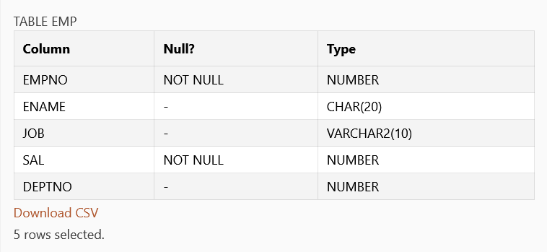

-- 7.

ALTER TABLE dept MODIFY dname varchar(30)

DESC dept

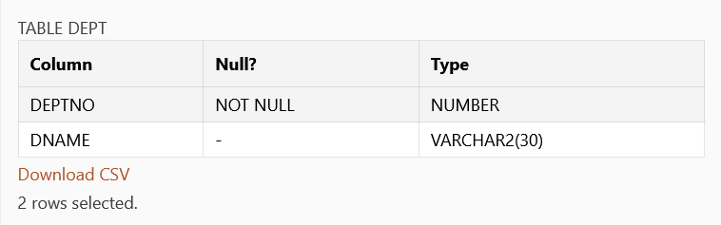

-- 8.

ALTER TABLE emp ADD comm number(10)

DESC emp

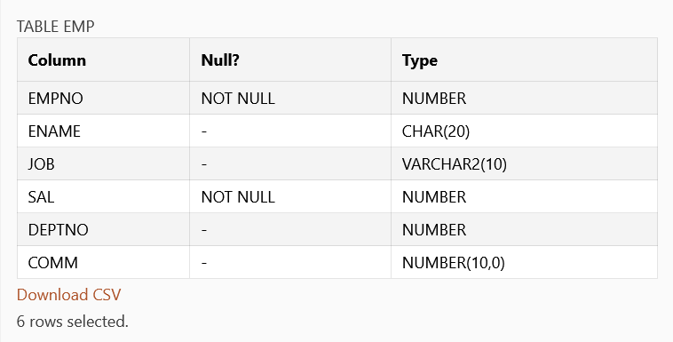

-- 9.

ALTER TABLE J drop column city

DESC J

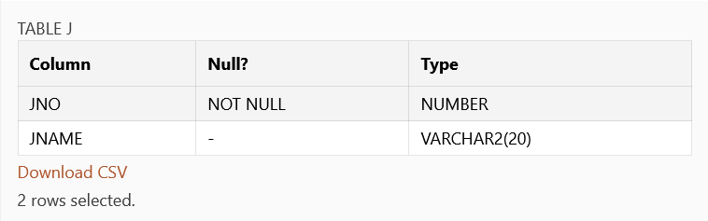

-- 10.

CREATE TABLE dup AS SELECT * FROM emp

SELECT * FROM dup

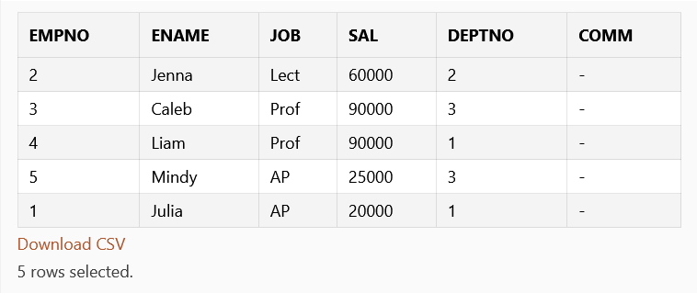

-- 11.

CREATE TABLE dcol(dupid,dupname) AS SELECT * FROM dept

SELECT * FROM dcol

SELECT * FROM emp

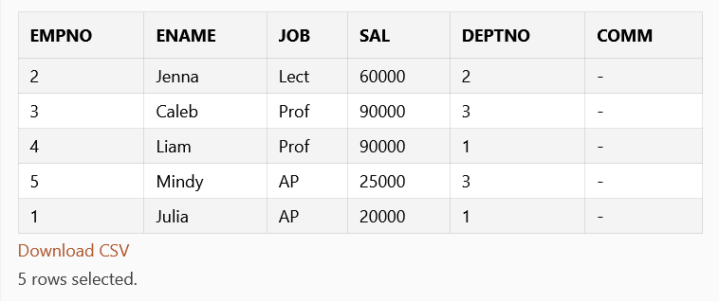

-- 12.

UPDATE emp SET ename='Miranda', job='Lect' WHERE empno=5

SELECT * FROM emp

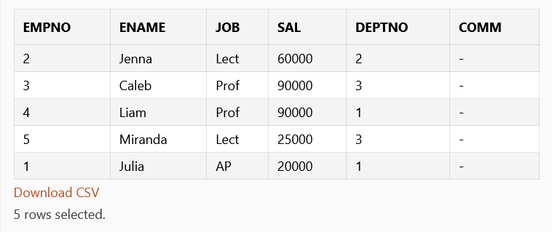

-- 13.

DELETE FROM emp WHERE job='comp'

DELETE FROM emp WHERE job='comp'

DELETE FROM emp WHERE deptno=1

SELECT * FROM emp

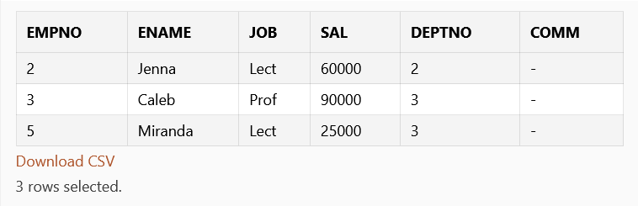

-- 14.

DROP TABLE dcol

-- 15.

DROP TABLE dup